Phillip Malone

Physics 1430 Lab 3 Experiment 4

Abstract: The purpose of this lab is to test kinematic equations that have been formulated to test the acceleration due to gravity. This is done by designing and completing two different experiments that influence an object due to gravity. One was given in the pre-lab homework with an object on a frictionless track tied to a free-falling object. The other was to be designed by the students conducting the experiment. We implemented the idea of putting one photo gate over the other and then dropping an object straight down through them. We found that gravity averages very close to the expected 9.81 m/s2.

Mathematical Model: The first equation is

a = ((Vf)2-(Vi)2)/(2*d)

a is acceleration. V stands for the velocity given by the photogates the subscripts determine which photogate number is put where with the second one being the final velocity and the first one being the initial. d is the distance between the photogates. The equation is crafted from the basic kinematic equations solved for a instead of Vf.

The second equation is

a = (mg)/(M+m)

a is the acceleration found in the first equation. m is the mass of the weight that is dropped. M is the mass of the object on the frictionless surface. g is the acceleration due to gravity or the variable we are looking for. The equation is made from using the idea of F = ma. You turn a into g for the y direction. If you didn’t it would be in the x direction. Then divide by the combined masses to account for the net force of the weight, represented by mg, pulling on the mass moving in the x direction.

Design: The experiment required two different tests that would determine the acceleration due to gravity. First collect the mass of the objects used in each experiment with a triple beam balance. For the first test the masses were 190.8 and 49.7 g for M and m respectively. We used the idea in the homework where a mass on a frictionless surface is connected to a weight dangling over a ledge around a pulley.

Shown here:

After releasing the weight, or m, the object on the frictionless surface, or M, will give you velocity at two points due to photogates set up in its path. With that you use the first mathematical model described earlier to give the acceleration in the x direction for M. After that is determined you use the second equation to give you acceleration due to gravity or in the y direction.

The second test used the two photogates one on top of each other where they could measure the velocity of a falling object.

Shown here:

Unlike the first test this one did not require the mass of the object. After obtaining the velocity of the object that fell through the gates, acceleration due to gravity was obtained through only plugging in variables for the first equation. Comparing the two numbers gives us a general idea of the strength of gravity at that point.

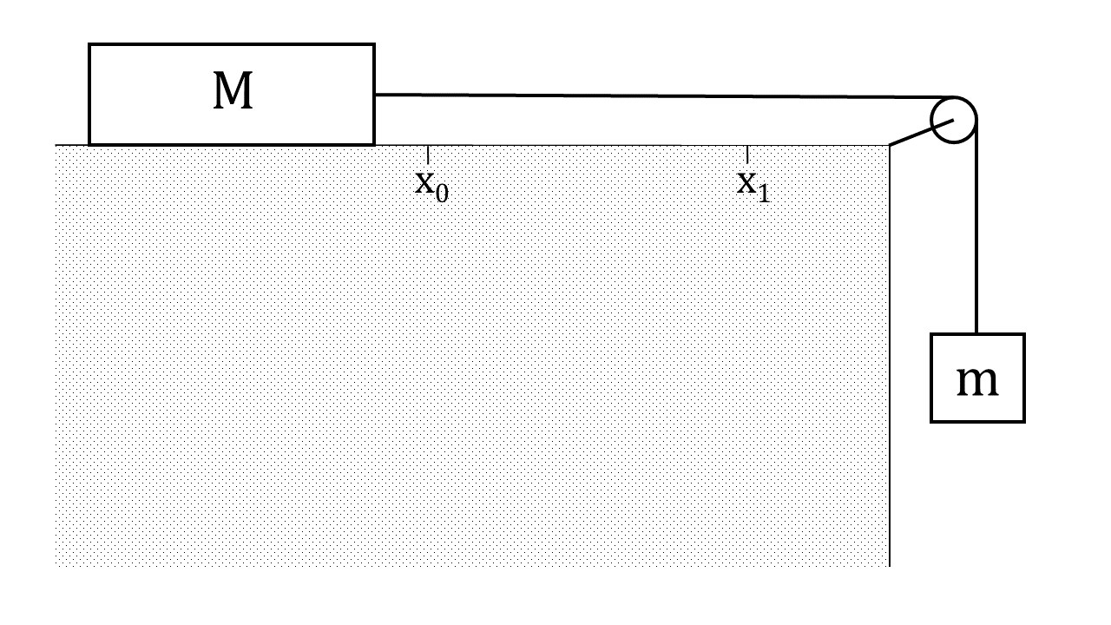

X0 and x1 represent the photogates. M represents the mass on the frictionless surface. m represents the mass that is dropped.

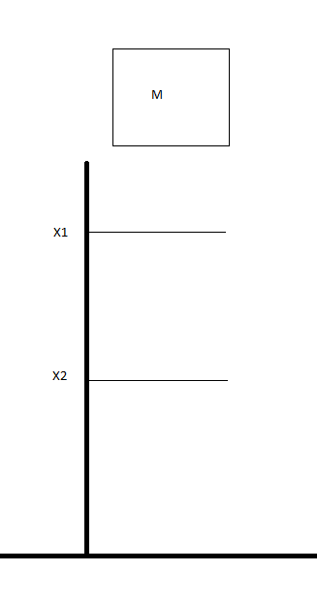

M represents the mass dropped. X1 and X2 represent the photogates.

Minimizing uncertainties: We readjusted the first test to the same height every time with the exact same objects used in the previous trials for that test. Also, we tied the rope around the entire base of the object on the frictionless surface to make sure it was an even pull on all sides. On the second test, we used a wallet and tied it up so that it wouldn’t flop around in the descent and we dropped it on the same side every time to prevent anything that might have been loose in there from moving around.

Results and Data Analysis:

|  |  |  |
| --- | --- | --- |
| Accel in the x direction Test 1 m/s2 | Accel in the y direction Test 1 m/s2 | Accel in the y direction Test 2 m/s2 |
| 1.879 | 9.093 | 10.019 |
| 1.886 | 9.126 | 9.827 |
| 1.853 | 8.967 | 10.246 |
| 1.856 | 8.981 | 9.927 |
| 1.890 | 9.146 | 8.651 |
| 1.859 | 8.996 | 9.510 |
| 1.833 | 8.869 | 10.163 |
| 1.838 | 8.894 | 10.327 |
| 1.831 | 8.860 | 9.952 |
| 1.834 | 8.875 | 10.715 |

Calculating test 1 results:

((1.489)2-(1.105)2)/(2(.265))

(2.217121-1.221025)/.53

.996096/.53 = **1.879 m/s2** <- acceleration in the x direction

We then use the answer we got to determine g

1.879 = 49.7g/(190.8+49.7)

1.879 = 49.7g/240.5

451.8995 = 49.7g

**9.093 m/s2 = g** <- acceleration in the y direction

Average for test 1:

(9.093+9.126+8.967+8.981+9.146+8.996+8.869+8.894+8.860+8.875)/10

98.701/10 = 9.8701m/s2

Calculating test 2 results:

(2.3282-1.0962)/ (2*.19)

(5.419584 – 1.201216)/.38

4.218368/.38 = **10.019 m/s2** <-acceleration for test 2

Average for test 2:

(10.019+9.827+10.246+9.927+8.651+9.51+10.163+10.327+9.952+10.715)/10

100.34/10 = 10.034 m/s2

Assumptions: We assume there is no air resistance in this experiment. If we factored in air resistance it would make the equations much more complicated as it would be for 2 or 3 objects in different directions. We also assume in the first test the string used to tie the two objects together and the pulley is massless. If we did not, we would have to get in to upper level thinking about how a string is made tight and how the mass of the pulley could affect the rope. We also assume when the object in the second test is dropped there is no jerk reaction from the person who releases it to speed it up. If we don’t consider this for test two it is possible to get weird numbers for gravity like 11+ m/s2. With this assumption and our standard idea of 9.8m/s2 we can stop ourselves from using very strange data.

Error Analysis:

First test

sqrt((9.093 – 9.8701)2 +(9.126 – 9.8701)2 +(8.967 – 9.8701)2 +(9.146 – 9.8701)2 +(8.996 – 9.8701)2 +(8.869 – 9.8701)2 +(8.894 – 9.8701)2 +(8.860 – 9.8701)2 +(8.875 – 9.8701)2 +(8.981 – 9.8701)2)/10)

sqrt((.60388441+.55368481+.81558961+.20620681+.76405081+1.00220121+.78517321+1.02030201+.99022401+.79049881)/10)

sqrt(7.71181539/10)

sqrt(.771181539) = +-.878 m/s2

second test

sqrt(Σ10k=1 (xk – 10.034)2/10) = +-.535 m/s2

Conclusion and Judgement: We can conclude that from this data that gravity in that area is very close to the standard 9.8 m/s2, or g, that we are taught to believe. While the second test has a higher gravity then the first if you average the two it comes out as 9.952 m/s2 which is very close to the standard g. That lets us get the idea that g is an average of the entire planet’s gravity at different points It is important that we had the assumptions to keep the equations simple and I feel that if we were to consider all the uncertainties and assumptions that it would be even closer to the standard g.

1. Are two values you obtained for gravitational acceleration consistent with each other? Consider assumptions and uncertainties. If you use the assumption for the second test more liberally some of the more extreme data that was collected would be replaced with things closer and closer to 9.8 m/s2. So, the way it is used in this experiment no the results aren’t really consistent but in a more controlled and more precise way of doing it they would be.

2. If they are different, what are possible reasons? Most likely the only reason they are different is the object dropped for test two was dropped by a human hand thus making the data slightly affected by human error.

3. Compare the values with the accepted value. Can the measured value be more than the accepted one? Can it be less? Which measurement is more? Which is more precise? Our measurements can be more or less because 9.81m/s2 is most likely an average for the entire planet so there is a possibility that there would be a stronger gravitational pull at some points. Technically both averages of both tests are greater than the standard 9.8 m/s2. The first test however is more precise because there is less room for human error in it.

4. Why do you have to conduct two independent experiments of g? Think about systematic uncertainties! If there was a problem inherently wrong with one test, then the other test should definitely provide us with the answer we were looking for. Plus it reinforces the idea that gravitational acceleration is 9.8 m/s2 with two separate tests that were very close to that number.